

**An Investigation into the Impact of a Stress Treatment on the Abundance of the Euryarchaeota Microbe in Cattle**

Shane O’Sullivan, Higher Diploma in Data Science and Analytics 2019

Supervisor: Paul Walsh

Shane.p.osullivan@mycit.ie

Abstract: (14pt)

With the recent global environmental protests and growing public awareness of methane’s destructive contribution to global warming, agriculture and in particular, cattle farming has been highlighted as a vital area through which enormous emissions reductions must be targeted.

The purpose of this project is to investigate whether the introduction of a stress treatment affected the abundance of the Euryarchaeota microbe within the digestive systems of Bos Taurus (cattle). The project sought to investigate this microbe’s abundance due to the microbe’s ability to produce methane. To examine the effect of this treatment one control group and one testing group were established. The effects of varying diet and residual feed intake on the relative abundance of the Euryarchaeota microbe were also examined, given the success of numerous studies on this topic. Samples were taken from the cattle at three separate points: prior to the initial injection, after the third of three injections and a final sampling point. To determine the effect of the treatment, T-tests and ANCOVA modelling techniques were utilised to determine if a decline in this microbe’s relative abundance took place. The analysis did not find any statistically significant impact on the relative abundance of the Euryarchaeota microbe due to the treatment. However, the diet of cattle and the residual feed intake were shown to have an impact, with a primarily concentrated feed diet resulting in a reduced Euryarchaeota microbe relative abundance compared to a primarily grazing diet and a low residual feed classification indicated a reduced Euryarchaeota microbe relative abundance.

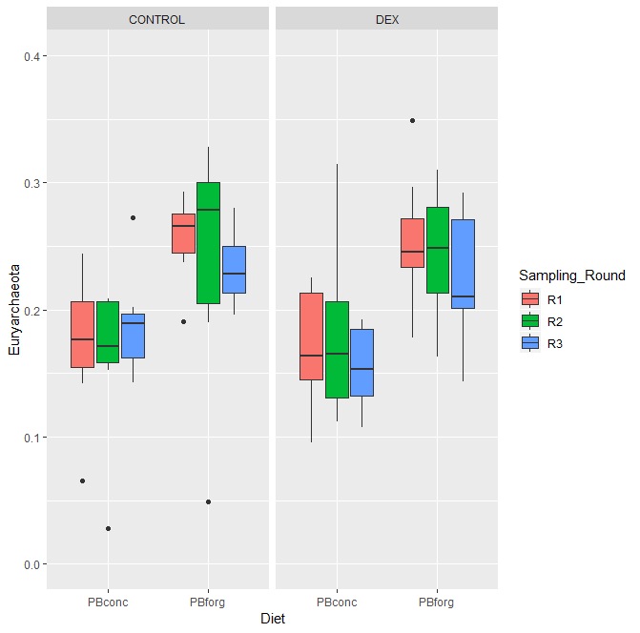

Figure : Boxplot Comparison of Euryarchaeota Microbe Relative Abundance per Sampling Round & Diet